**De Pere Business Talks**

**September, 2022 Retention Visit Findings**

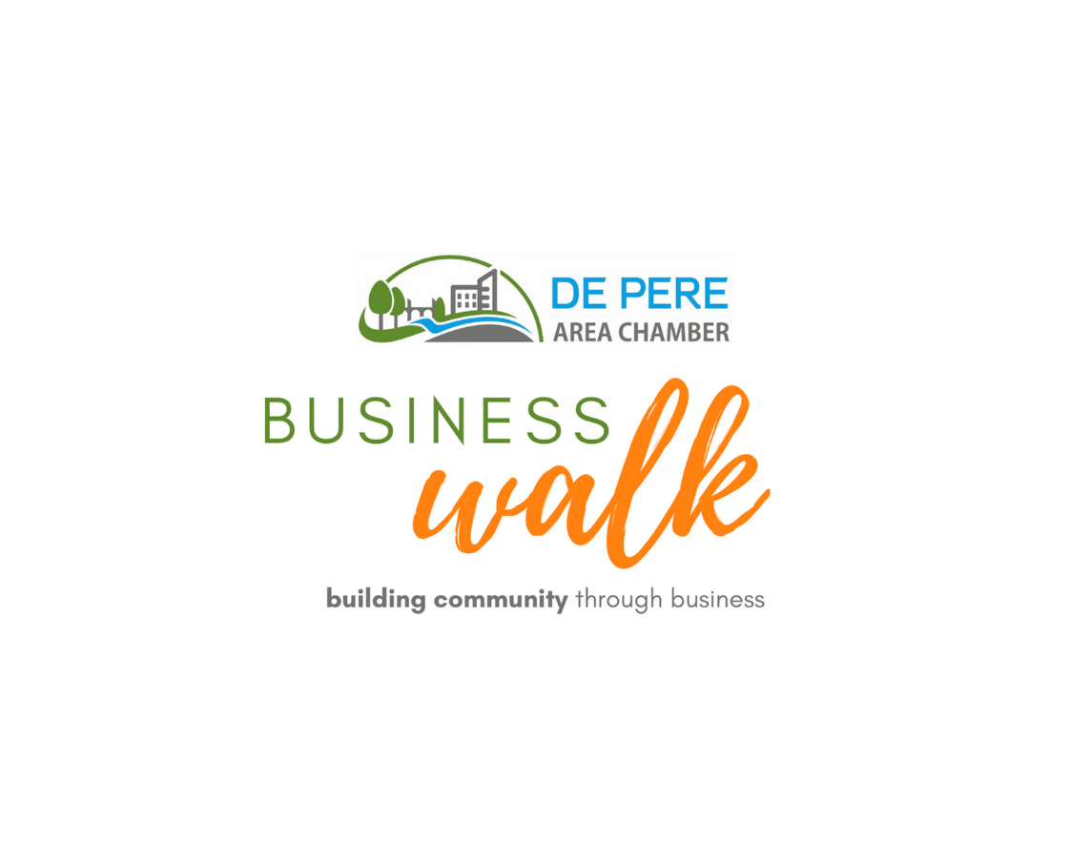

**Presented by:**

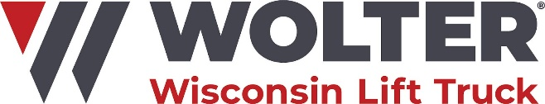

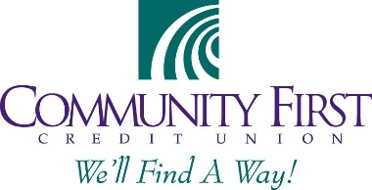**Volunteer Sponsor:**

**In Partnership with:**

****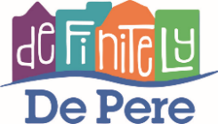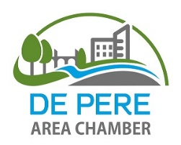 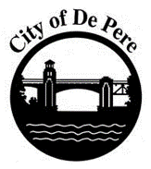

**Business Talk Highlights**

The 2022 business talk included both in person visits and online responses. The combined effort resulted in 120 business responses – down just under 15% from pre-COVID in-person efforts. Participating businessse provided valuable input regarding the current state and near-term outlook for the business climate in De Pere. Key findings included:

* Businesses have largely rebounded to pre-pandemic revenues, although certain sectors are subsequently challenged by supply chain or labor constraints that are a drag on growth. More than 10 percent of surveyed businesses are new since 2019.
* Overall, the business climate in De Pere was ranked more favorably in 2022 than 2018 at 4.1 out of 5.0. However, there is more variability in response, with one-third of businesses dissatisfied with certain aspects of doing business in the community including rising costs, the pace of growth and shifting business patterns which rely less on local customers.
* Businesses remain optimistic about the future, with 83% of businesses planning to grow in the next five years. However, within this number are 16 businesses that indicated that their current location presented limitations to that growth, indicating potential retention challenges. Of the five percent planning to relocate in the next five years, cost was cited as a major reason for the move.
* There was significant interest by businesses in attending training offerings if available – more than half of businesses suggested one or more topics that would be of interest. Mornings are the preferred time for training, and attendees prefer a mix of formats between in-person and virtual sessions.
* A majority of businesses are positive about the benefits of community growth, seeing a chance to add customers and gain desired amenities. Only 7% specifically citing a desire to slow the pace of growth. However, businesses were intersted in additional networking and community events to ensure that new residents and businesses are able to connect with the community to retain the strong local network. Existing businesses also wanted incentives targeted at helping them grow and evolve, and in join strategies to effectively market to new audiences moving into the community.

A more detailed overview of the business talk process and more specific insights gained through the talk are included in the following sections.

**Business Talk Overview**

Business talks took place on September 27th, with online responses collected for another week following the visits. Volunteers visited businesses in the various geographic areas of the city as in previous years, although all visits were completed in the afternoon, rather than in two shifts. The 2022 business talk resulted in interviews of 120 businesses throughout the City, or just under 9 percent of City businesses. Interviewed businesses included a mix of in the City of De Pere including retail, service, construction and manufacturing firms. The talk, in its sixth year, was conducted in partnership with the De Pere Area Chamber of Commerce, the City of De Pere, Definitely De Pere, and the Wisconsin Economic Development Corporation and received support from Wolter and Community First Credit Union. The business talk is designed to take the pulse of the local business community, uncover opportunities and challenges for doing business in the De Pere area, and identify ways that local partners can help enhance and grow the local economy and create a business friendly environment. This year, the talk also explored the extent to which the COVID-19 pandemic is still impacting business performance.

**Business Respondents**

Businesses responding to the question represent a diverse mix of industries, as illustrated in the chart at right. Service businesses (personal and professional) represented 35 percent of businesses interviewed, retail and restaurant accounted for another 37 percent, and the remaining businesses were engaged in manufacturing, warehousing, distribution, contracting and healthcare. This is very similar to prior years and the overall composition of businesses in the City.

While last year’s survey found significant differences in business performance by industry type, in 2022 industry played a smaller role in business optimism. For example, in 2021 more than half of restaurants had yet to recover, while this year 2/3 are back to pre-pandemic revenues. Similarly, few if any healthcare or manufacturing businesses were experiencing decline last year, while in 2022 10-15% of busineses in these sectors reported revenues below 2019 levels. However it should also be noted, the only businesses indicating an actual decline in business from 2019 to 2022 were retail and restaurant businesses, with certain individual businesses unable to retain their former market share.

**Survey Results**

***Business Climate***

The first business walk in 2018 asked businesses to rate the business climate on a scale of 1-5 with five representing a supportive business environment. That year, the average score was 4.0. In 2022, when asked the same question, the average score was 4.1 out of 5. However, in 2018 only two businesses ranked the local business climate below average (both of which were looking to relocate). In 2022, this number had risen to 5 businesses, with an additional 18 businesses ranking the climate as only average. With the increase in negative responses comes a corresponding number of businesses rating the business cliamte as 5 out of 5 – nearly one-third of respondents, up from one-quarter in 2018. From comments provided by each group, it is clear that some businesses were able to access local assistance programs and/or used the pandemic period to build business connections while others feel less connected to the community than previously. There were also a number of businesses with lower business climate rankings that indicated that either a large part of their business is now focused on markets outside of the community and/or that were unhappy with the amount and direction of development in the community.

***COVID-19 Impacts***

The first question of the survey asked businesses to reflect on current performance relative to 2019 or pre-pandemic performance. De Pere businesses in 2022 reported continued positive growth, with only 19% indicating less than a full recovery. However, within this group, it is evident that at least a portion of the ‘rebounded partially’ group had previously recovered, but is now seeing a decline in revenue caused by other factors, most notably supply chain or labor challenges. It is also worth noting that 13 businesses responding to the survey opened post-2019 and were unable to answer this question, highlighting the strong startup activity witnessed throughout the state in recent years. These new businesses were not limited to any one industry, but represented in virtually every sector surveyed.

***Future Plans***

Businesses in De Pere remain optimistic about the future, although slightly less so than prior years. In 2022, 83% of businesses anticipate growing locally, while 5% anticipate relocating (cost was mentioned several times as a factor). Four businesses anticipate closing/retiring in the next five years (a similar number to prior years), while the remaining ten percent anticipate stable conditions. Of those hoping to grow in De Pere, 18 percent also plan to grow in other markets.

Several of those reporting no planned changes indicate that they would prefer to grow, but lack of workforce will likely prevent growth from occurring. Similarly, it is notable that 16 business indicated that their current space does not meet their needs, with most citing space or layout constraints as a primary factor. Space limitations were also the primary factor driving three businesses to report a plan to leave the community in the next five years. Seven businesses also identified a lack of parking as a constraint of their current location, although none of these businessed incated a plan to relcoate as a result of this challenge.

***Leveraging Growth***

Respondents were asked to identify any specific opportunities that they saw for De Pere to leverage its ongoing growth and development to boost existing businesses. Only half of respondents replied to this question, but among those that did:

* 9% of businesses are thrilled with everything that is happening, while 7% would like to see De Pere focus on cutting taxes and preserving its history.
* Many businesses focused on strategies to maintain the cohesion and connection as a community while growing – examples include the 15% of businesses that desire additional networking, communciations and business directories to ensure that local businesses know each other, and the 12% of businesses that would like to see more community events to encourage gathering and residents that know each other and come together.
* Other businesses focused on the opportunity to build the economy in ways that benefit their business – specifically by adding more small businesses (6%) amenities (6% - daycare, restaurants, industrial businesses), and residents/workers (5%)
* Similarly, other businesses focused on mitigating challenges from growth such as transportation concerns (9% - bridges, bike/ped connections) and parking challenges (9%)
* Lastly, the remaining responses focused on helping existing businesses to grow and evolve along with the city, specifically by helping businesses advertise/market to new customers (9%) or providing incentives targeted at the growth and expansion needs of existing businesses (6%). Several also suggested that the downtown footprint should grow, and/or grow by including walkable multi-family options to reduce sprawl and maintain a strong core.

***Interest in Programs and Services***

Businesses were asked two questions related to their interest in services from the Chamber and other partners. First, they were asked if they are interested infuture trainings, and, if so, which meeting format best meets their needs. Second, they were asked to identify training topics that are particuarly useful for their business.

It is particularly interesting that every surveyed business responded to the preferred training structure question, seeming to indicate that most businesses have at least some interest in attending training where topics are relevant.

Morning was by far the most popular training time – this time was preferred by every industry except restaurants, who often have late-night hours and therefore prefer lunchtime training sessions.

The preferred training format varies greatly, with roughly equal preference for all meeting types. Manufacturing was the only sector that had a strong preference for virtual, while retail had the strongest preference for in-person sessions.

The following table summarizes the topics identified as most relevant/useful by category.

|  |  |  |
| --- | --- | --- |
| Category | Number Responding | Examples |
| Government /Business 101 | 9 | Sales/Use Tax, History of De Pere, Public Safety, St. Norbert Programs, Tourism, Apprenticeship/Intership Program, Quickbooks, IT |
| Employee/Workforce | 10 | Generational Training, Retention & Attraction, Team Building |
| Personal Growth | 8 | Emotional Intelligence, Leadership, Networking Group |
| Skills-based | 17 | Customer Service, Conflict Management, Sales, Tax Planning, CPR |

An additional follow-up question asked respondents to identify wasy that the partners can be a resource to businesses. Many of the responses here echoed sentiments previously expressed (specifically a desire for assistance in advertising and networking opportunities), although several businesses did indicate that they are unsure what the various organizations do within the community, or how to engage. There were some constructive ideas shared, including; a community job board, the need for joint insurance plans and a desire for formalized business referral systems.

***Other Input/Feedback***

Businesses were asked to share any other successes or challenges that they wanted organizers to know. The items shared were evently split between challenges and success stories, including the topics listed below. Several also used this space to indicate that they would like to sign up for newsletters/communciations.

Successes:

* 4 business anniversaries
* 3 new owner announcements
* 2 business award/storytelling share
* 2 business expansion/service announcements
* 1 compliment of streetscape improvements
* 1 request for talking points on benefits of various projects to share with employees/customers

Challenges:

* 6 workforce shortages
* 3 signage/zoning complaints
* 3 traffic/parking complaints
* 2 taxes/healthcare costs/rent challenges
* 1 business closing
* 1 perception that west side has been overlooked

***Survey related feedback***

Respondents were asked if they had any recommendations for future survey questions. The following were suggested:

* Understand which services are used by businesses, where they see value
* Connect businesses with volunteer networks (to access volunteers or offer employees volunteer options)
* Inflation impacts
* Successful advertising strategies
* How/if social issues are impacting business.
* Talent shortage implications/strategies
* Demonstrating commitment to community – how are/could be involved

***Follow-up***

The most important element of a business talk is the opportunity to follow-up with individual businesses regarding specific challenges, and to identify strategies or inititaives that will be undertaken as a result of the information learned during the survey. Of those surveyed, 41 provided contact information and expressed an interest in individual follow-up from one or more partners. Three-quarters provided an email and requested a copy of the survey results.

For future communications planning, it should be noted that only one-quarter of respondents had not heard about the business walk previously, down significantly from the half of respondents in 2021 that received no communciations.

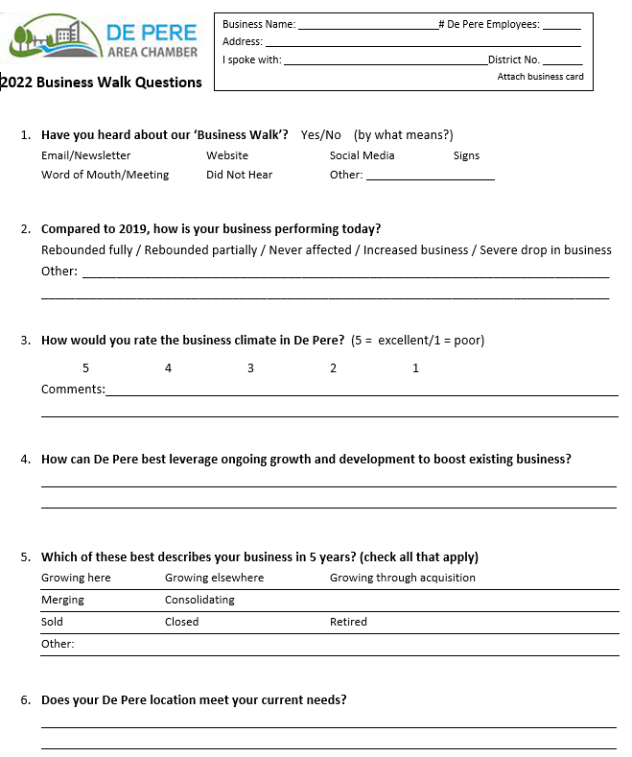

**Business Walk Questionnaire**

