**De Pere Business Talks**

**October, 2023 Retention Visit Findings**

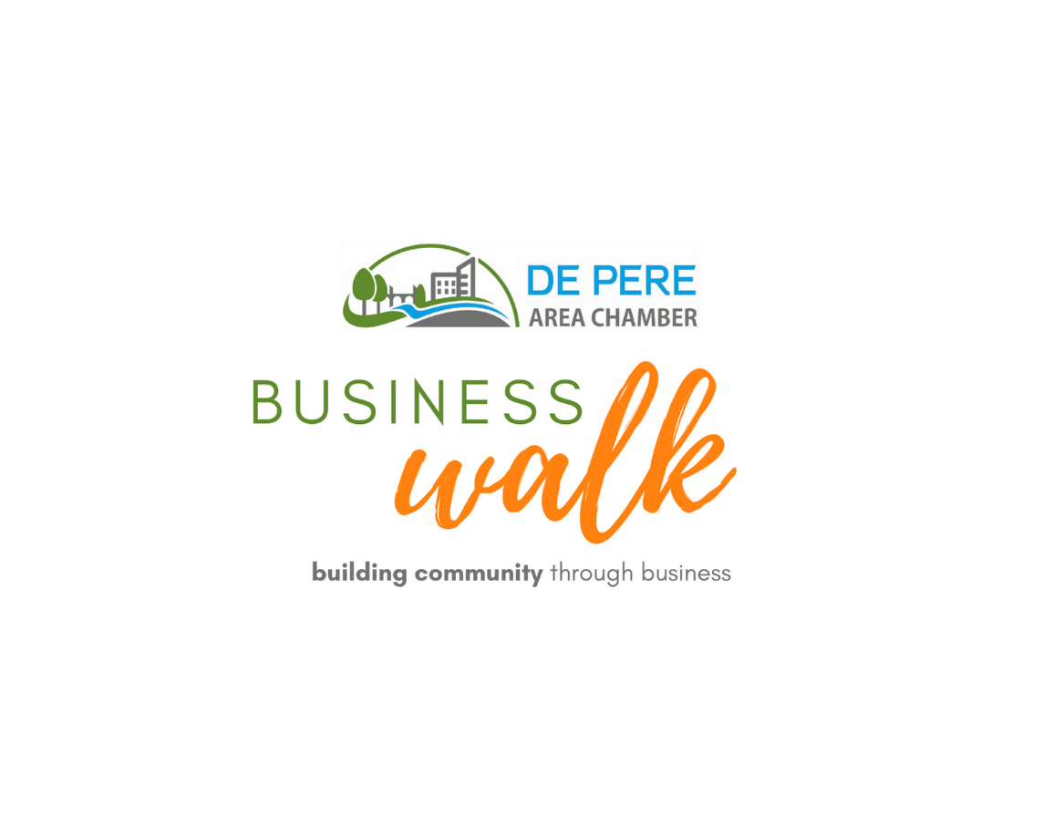

**Presented by:**



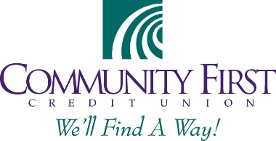**Volunteer Sponsor:**

**In Partnership with:**

****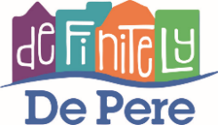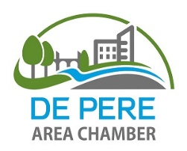 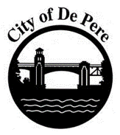

**Business Talk Highlights**

The 2023 business talk included both in person visits and online responses. The combined effort resulted in 89 business responses – down by 25% from pre-COVID efforts. Participating businessse provided valuable input regarding the current state and near-term outlook for the business climate in De Pere. Key findings included:

* Businesses seem to have determined that their performance has stabilized and that current performance is likely a good gauge for the future. While this was generally positive, with half of businesses experienced steady growth, more than 30 percent reported flat or negative sales in recent years.
* The average business climbing ranking climbed again in 2023 to a high of 4.25 out of 5. Only three businesses ranked the climate as below average, and two of these are new and reported slow sales to date. Construction, healthcare and manufacturing were the most positive, while hospitality and restaurants provided the lowest average ratings.
* Businesses remain optimistic about the future, with 78% of businesses planning to grow in the next five years (down from 83% in 2022). However, within this number are 8 businesses that indicated that their current location presented limitations to that growth, indicating potential retention challenges. Of the seven percent planning to relocate in the next five years, expansion space and parking challenges were identified as drivers.
* Half of businesses were interested in being more involved with community events, with many open to sponsoring, partnering or volunteering.
* While 64% of businesses expressed some level of effort/desire to shop or source locally, many did not seem to feel that this question applied to their business, or did not understand what sourcing locally looked like for businesses. Additional education may be needed to increase awareness/engagement among businesses about the benefits of supporting local.
* In keeping with previous years, many respondents understood that new development and growth were opportunities, but several expressed concerns about changing character, increased traffic and rising rents/costs as a result of these initiatives.

A more detailed overview of the business talk process and more specific insights gained through the talk are included in the following sections.

**Business Talk Overview**

Business talks took place on October 3rd, with online responses collected for another two weeks following the visits. Volunteers visited businesses in the various geographic areas of the city as in previous years, although all visits were completed in the afternoon, rather than in two shifts. The 2023 business talk resulted in interviews of 89 businesses throughout the City, or just under 12 percent of City businesses. Interviewed businesses included a mix of in the City of De Pere including retail, service, construction and manufacturing firms. The talk, in its seventh year, was conducted in partnership with the De Pere Area Chamber of Commerce, the City of De Pere, Definitely De Pere, and the Wisconsin Economic Development Corporation and received support from Wolter and Community First Credit Union. The business talk is designed to take the pulse of the local business community, uncover opportunities and challenges for doing business in the De Pere area, and identify ways that local partners can help enhance and grow the local economy and create a business friendly environment. This year, the talk also explored business operations topics including local supply chains and marketing strategies.

**Business Respondents**

Businesses responding to the question represent a diverse mix of industries, as illustrated in the chart at right. Service businesses (personal and professional) represented 41 percent of businesses interviewed, retail and restaurant accounted for another 33 percent, and the remaining businesses were engaged in manufacturing, warehousing, distribution, contracting and healthcare. This is similar to prior years, although fewer manufacturing and construction/real estate firms participated this year.

While COVID-era surveys shows a distinct difference in business performance and outlook by industry type, that is no longer the case. Nearly ever sector had businesses indicating a drop in business, as well as an increase. As an example, in the personal services sector, 2 businesses experienced a drop in business and negative future outlook, but two others just opened and are optimistic about the future.

There was a slight difference in the business climate rating by industry, with hospitality businesses providing the lowest overall score, followed by restaurants. Construction, healthcare and manufacturing provided the highest average business climate ratings (although relatively fewer of these businesses responded overall).

**Survey Results**

***Business Climate***

The first business walk in 2018 asked businesses to rate the business climate on a scale of 1-5 with five representing a supportive business environment. That year, the average score was 4.0. In 2022, when asked the same question, the average score was 4.1 out of 5, and this year, the average was 4.24, indicating continued positive perceptions of the local economy. Only three businesses ranked the business climate as below average this year, and two of the three are new and reported very slow sales traffic so far.

More than one-third of respondents gave the local business climate a 5 out of 5 rating, the highest number yet, up from one-quarter in 2018. While in prior years contentment was due in part to state grant funds and overall community growth, but this year most of the highest ranking businesses just expressed positivity about the community, its residents and other business owners over any specific policies or economic opportunities.

***Business Performance***

Businesses were asked to indicate how their business has performed in the past few years. This is the first year where the recovery metrics were not tied to pre/post COVID assessment. Businesses were generally positive, but slightly less so than prior years – many seemed to accept that today’s market is largely where it has stabilized post-COVID, while in prior years they still hoped for additional improvement. As a result, 49% indicated that business has increased over previous years, 29% reported business at stable levels over the past few years and the remaining 8% reported declining business. Ten businesses did not respond to the question because they were too new to compare prior years.

***Future Plans***

Businesses in De Pere remain optimistic about the future, although slightly less so than prior years. In 2023, 78% of businesses anticipate growing locally (down from 83% last year), while 7% anticipate relocating (limited property availability was mentioned by two businesses). Five businesses anticipate closing/retiring in the next five years (a similar number to prior years), and four plan to expand elsewhere while remaining in De Pere, while the remaining seven percent anticipate stable conditions. Of those growing in De Pere, 16% also plan to expand elsewhere.

Businesses were also asked about any limitations to their current location. The vast majority responded positively – 70% indicated satisfaction with their current location, and five even indicated that their landlord was a huge asset (not something seen in many communities). Of those that identified challenges, 5% had expansion plans that could not be accommodated, one felt that the property was dated, and the remaining 9% indicated that parking (for both employees and customers) was a concern.

***Marketing & Customer Growth***

Businesses were asked several questions related to marketing and customer acquisition. The first question asked them to identify the most impactful way they attract new customers. Given the high level of community pride and engagement expressed by survey respondents, word of mouth and referrals/networking were the two most frequently mentioned strategies, followed by direct communications such as social media and newsletters. Only a few reported success with paid advertising.

The second marketing question asked if there was any marketing assistance that local partners could provide that would be valuable. Ten percent indicated that they have in-house marketing and do not need assistance, and 39 percent reported that they do not need any help in this area. Of those that would like assistance, 13% indicated a general need for assistance/that they would like help, but did not specify. 5-7% each identified the following specific needs:

* More business features (by all partners) on social and in newsletters
* A list/directory of all local advertising opportunities. Many didn’t know where to look (including events)
* Marketing locally – to chamber members, to new residents, students, advertising options in newsletters.
* Social media training (or other topical training)
* Continue/add networking events
* Explore wayfinding signs/guides for busiensses.

***Interest in Involvement***

The final two questions asked businesses whether they were interested in partnering, sponsoring or volunteering for community events, and the degree to which they prioritized shopping/sourcing from local businesses.

Roughly half of businesses (53%) were intersted in being more involved in some way. This includes 24% of businesses that expressed openness to partnering, sponsoring or volunteering. An additional 11% were interested in volunteering, and 7% each were interested in partnering and/or sponsoring.

With regards to shopping local, 64% of businesses indicated some level of support for shopping/sourcing local when it came to their business. Of the remaining businesses, 26% either indicated that there were no local sources for their supplies, there was not the quality of product needed, or felt that the question did not apply to their business. Several additional respondents indicated that personally they try to shop local, but their business does not, and the remainder indicated that they support shopping local and then proceeded to list national chains in De Pere or Green Bay that they frequent. It is clear that there is room for additional education on this topic or perhaps marketing celebrating businesses that do prioritize this in their business.

***Parting Thoughts***

Businesses were given one last opportunity to provide any other feedback that they wanted to share, either more details realted to their answers, or input on questions not covered in the survey. The following are representative of the topics introduced in the survey

Business Specific:

* Would like more to be done with fake IDs collected, or to prevent them – they often pass the scanner now.
* Watertower is causing runoff and issues in parking lot and foundation
* Recruiting is still a challenge.

Parking/Traffic:

* Please open parking lot up in the winter.
* Snow plowing makes parking a challenge in winter.
* Parking issues in private spots behind businesses, how to enforce?
* Traffic through downtown is way too high for quality pedestrian experience

General:

* Appreciate what Mulva/Shopko development will do, but concerned about character, rising rents/prices.
* Love the hanging baskets and plants, how can we have them longer
* Could have events that attract new/different audiences
* Need to be open to change.
* Address prison issue.

***Follow-up***

The most important element of a business talk is the opportunity to follow-up with individual businesses regarding specific challenges, and to identify strategies or inititaives that will be undertaken as a result of the information learned during the survey. Of those surveyed, 25 provided contact information and expressed an interest in individual follow-up from one or more partners, including 5 specifically identifying the City and four the Chamber. Just over half (down from 75% last year) provided an email and requested a copy of the survey results.

For future communications planning, more than 40% of respondents this year reported hearing about the walk, up from under 25% in each of prior years. This includes the 16 that heard about it in a meeting and filled it out online, but also a number of individuals that participated in past walks or saw it on social media.

**Business Walk Questionnaire**

