**De Pere Business Walk**

**October, 2024 Retention Visit Findings**

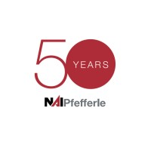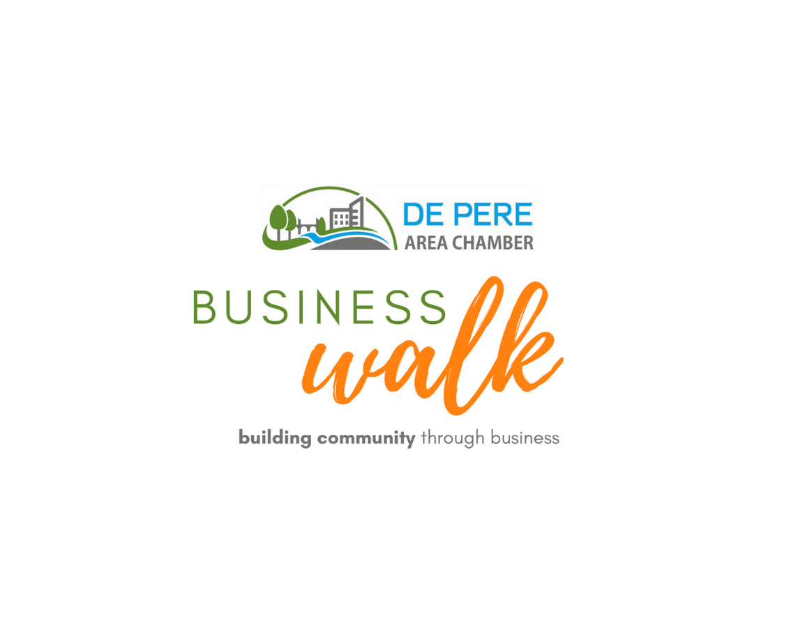

**Volunteer Sponsor:**

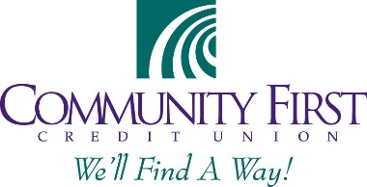**Lunch Sponsor:**

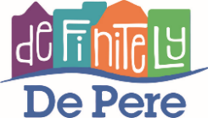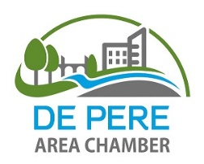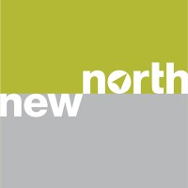**In Partnership with:**

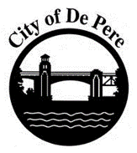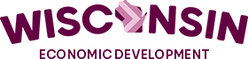

**Business Walk Highlights**

The 2024 business talk included input from in-person visits and online responses. The combined effort resulted in 62 business responses – down by 30% from 2023 and nearly 50% from pre-COVID efforts. Participating businesses provided valuable input regarding the current state and near-term outlook for the business climate in De Pere. Key findings included:

* De Pere’s average business ranking climbed again in 202 to a high of 4.27 out of 5. No businesses ranked the business climate below average, and of the five that gave it an average ranking, two indicated that their business is not reliant on the local economy.
* Business performance has stabilized post-COVID, with nearly half of businesses reporting stable business over the past few years, while a healthy 38% have experienced growth.
* Businesses again remain optimistic about the future, with a consistent 81% of businesses planning to grow in the next five years (10% of these will also grow elsewhere). Also consistent were the five businesses that plan to retire or sell and four planning to remain in De Pere while expanding elsewhere.
* 90% of businesses are satisfied with their current location, and 70% are not interested in information on alternative financing, as they have no present improvement plans. Those interested in funding assistance were contemplating property purchases or façade renovations.
* When asked about hiring, 30% report being fully staffed. Only 25% reported actively hiring at present, although one-third are interested in engaging with interns, apprentices, or job shadow programs.
* More than 75% of businesses reported a business partnership with at least one community organization, and 26% reported engaging with multiple community partners. 36% of businesses were interested in partnering, engaging, or volunteering in the coming year, including 12 businesses that did not indicate a current partnership.
* General business concerns and comments were similar to previous years – pride in the continued growth and investment in De Pere, coupled with concerns over parking, traffic, and the retention of De Pere’s character.

A more detailed overview of the business talk process and more specific insights gained through the talk are included in the following sections.

**Business Talk Overview**

Business talks took place on October 2nd, with additional online responses collected in the weeks following the visits. Volunteers visited businesses in the various geographic areas of the city as in previous years, although teams were instructed to prioritize businesses in each geography identified as not currently engaged with visit partners or having participated in prior walks.

The walk, in its eighth year, was conducted in partnership with the De Pere Area Chamber of Commerce, the City of De Pere, Definitely De Pere, New North, and the Wisconsin Economic Development Corporation and received support from NAI Pfefferle and Community First Credit Union. The business talk is designed to take the pulse of the local business community, uncover opportunities and challenges for doing business in the De Pere area, and identify ways that local partners can help enhance and grow the local economy and create a business-friendly environment. The 2024 business talk resulted in interviews with roughly 5 percent of City businesses. The reduced share of businesses is a result of fewer interviews conducted and growth in De Pere businesses. This year, additional questions were added regarding existing relationships in the community and the desire, if any, for increased engagement with civic organizations.

**Business Respondents**

Businesses responding to the question represent a diverse mix of industries, as illustrated in the chart at right. Service businesses (personal and professional) represented 52 percent of businesses interviewed, retail and restaurant accounted for another 21 percent, and the remaining businesses were engaged in manufacturing, warehousing, distribution, contracting and healthcare. This mix is similar to prior years, although in comparison to City-wide industry mix it over represents retail businesses and under repesents healthcare and restaurants.

**Survey Results**

***Business Climate***

The first business walk in 2018 asked businesses to rate the business climate on a scale of 1-5 with five representing a supportive business environment. That year, the average score was 4.0. In 2022, when asked the same question, the average score was 4.1 out of 5, in 2023 it was 4.24 and in 2024 it was 4.27 indicating continued positive perceptions of the local economy. No businesses ranked the business climate as below average and only five ranked it as average. Two of those providing an average ranking indicated that their business is not reliant on the local business climate.

Once again this year, more than one-third of respondents gave the local business climate a 5 out of 5 rating, up from one-quarter in 2018. Many businesses with this type of positive perception of the climate also mentioned one or more new developments, and indicated that overall they felt De Pere is thriving.

***Business Performance***

Businesses were asked to indicate how their business has performed in the past few years. Businesses were generally positive, although a greater percentage reported overall stability rather than growth or decline. In all, 38% indicated that business has increased over previous years, 45% reported business at stable levels over the past few years and the remaining 13% reported declining business. Two businesses did not respond to the question because they were too new to compare prior years. There were no industry trends related to business performance.

***Future Plans***

Businesses in De Pere remain optimistic about the future at similar levels to all post-COVID years. In 2024, 81% of businesses anticipate growing locally. Five businesses anticipate closing/retiring in the next five years (a similar number to prior years), and four plan to expand elsewhere while remaining stable in De Pere. Of those growing in De Pere, 10% also plan to expand elsewhere. Unlike prior years, no businesses indicated plans to relcoate within the community.

Businesses were also asked about any limitations to their current location. The vast majority responded positively – 90% indicated satisfaction with their current location, and two have already made arrangements to accommodate future growth. Of those that identified challenges, one is moving shortly to a purchased building in Green Bay, and others need more space or more visibility than their current space can accommodate.

Businesses were also asked if they were currently hiring, and, if so, for what type of employees. As shown in the graph at right, 25% of businesses are actively hiring while 30% are fully staffed. An additional 15% are not actively hiring, but seeking skilled or experienced workers. Nearly one-third of businesses are intersted in working with interns, apprentices or job-shadow programs, including both companies that are currently hiring as well as those that are fully staffed.

Companies were given the opportunity to share successful hiring strategies, but only one company indicated that Indeed is their preferred platform. Several respondents expressed a desire to learn more about intern and job shadow opportunities.

***Funding & Partnerships***

Businesses were asked several questions related to their desire for additional services or partnerships with civic organizations. The first question asked about their level of interest in alternative funding sources. Surprisingly, 2/3 of businesses were not interested in alternative funding (although, no information was provided about what funding sources might apply to). 18 businesses did express interest, specifically for funding that would assist with the following information:

* Façade improvements
* Assistance to purchase current property

It is important to note that of these 18, four specifically indicated that they were only interested in grant funding.

Businesses were also asked what civic organizations they currently partner with, and whether they’d be interested in partnering, sponsoring, or volunteering at community events in the next 12 months. More than 75% of businesses indicated having a relationship with one or more civic partners, and 26% indicated partnerships with more than one organization.

Regarding their interest in future partnerships, 48% were not interested in engaging with civic organizations in the coming year. 16 businesses were interested in partnering, 17 in sponsoring, and 12 in volunteering (overall 36% were interested in one or more of these activities, including 12 businesses that indicated they do not have a current relationship with any of the identified civic organizations).

***Parting Thoughts***

Businesses were given one last opportunity to provide any other feedback that they wanted to share, either more details related to their answers, or input on questions not covered in the survey. The following are representative of the topics introduced in the survey:

Business Specific:

* Desire to announce/celebrate the business anniversary with marketing assistance
* Difficulty with retaining youth employees, frequent quitting
* Need a new sign, unsure how to go about it
* Business offers space as an incubator, interested in engaging with the Chamber, potentially funding or formalizing the program.

Parking/Traffic:

* Honey Court is dangerous with the amount of truck traffic and on street parking
* Library parking is a challenge
* Still waiting for the bridge – the decision to locate in their space was contingent on that

General:

* Organizations make decisions without consulting businesses
* Concerned Shopko will change historic look of downtown
* Power outages are more frequent lately.
* Organizations don’t always equally serve businesses

***Follow-up***

The most important element of a business talk is the opportunity to follow up with individual businesses regarding specific challenges and to identify strategies or initiatives that will be undertaken as a result of the information learned during the survey. While overall participation in the survey was down this year (the impending election and overwhelming amount of campaign outreach were identified as a potential cause), significantly more participants requested specific follow-up this year, with 37% of respondents requesting specific follow-up, up from the 20-25 percent in previous years. Just over 40% provided an email and requested a copy of the survey results, significantly fewer than in previous years.

For future communications planning, more than 39% of respondents this year reported hearing about the walk, similar to last year’s rate and up from under 25% in each of prior years. This includes a mix of individuals who had heard about it from email or social media and those who attended a meeting or participated in a prior walk.

**Business Walk Questionnaire**

